**TRF ROBOSOFT IMAGE PROCESSING TASK-2**

**GROUP 2-**

1. **Aishwarya Satpute**
2. **Siddhi Mukkawar**

**3) Shubham Ghyatadkar**

# Task- Apply Filter and color Masking Using Mouse event

## 11th Sept 2020

We were given task related to Mouse Event . The aim is to apply filter and color Masking using mouse event to the image and real time . In the first meet we decided to do individual research and then finalize the approach.

## 12th September 2020

Read about Mouse event and methods to apply filter using Mouse event .

**13th September 2020 -14th September 2020**

We tried different codes and approaches to solve our problem. Then we did the code which was used to apply blur,GaussianBlur,medianBlur,bilateralFilter,box filter using mose single click on image .

a)output before applying filter

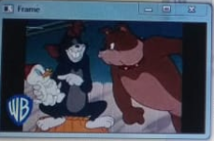

b) After applying filter

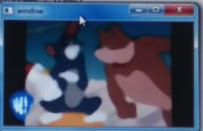

**15th September 2020-16th September 2020**

we updated code for double click to apply filter on image And started working for real time implementation .then we completed the code for applying filter in real time.

1. Output Before applting filter

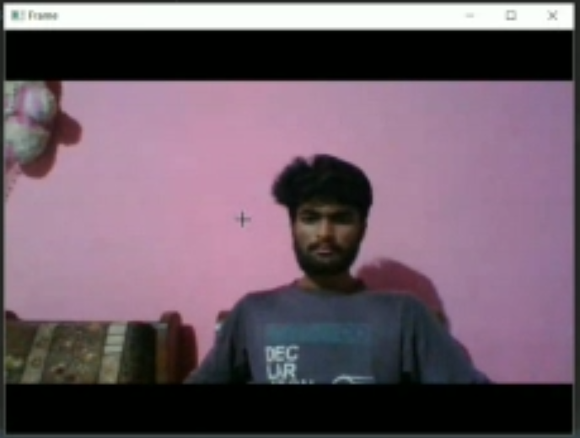

1. Output after applying filter

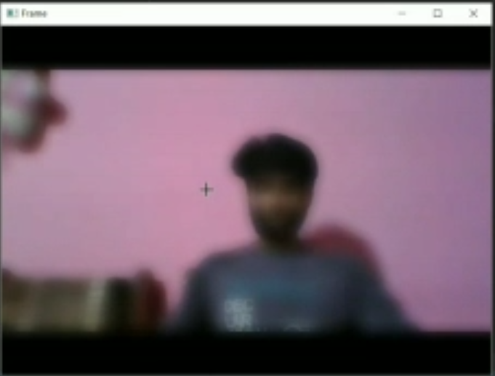

**17th September 2020**

Presented output of the previous code. Some improvements suggested and further task given by mentors as follows:

1. Masking on image and real time
2. Use mouse event to apply masking the specific color
3. Add more features using keyboard

**18th September 2020**

we started working on given improvement , first we did individual research . then we completed code for masking color in real time but it was only for red color .

a)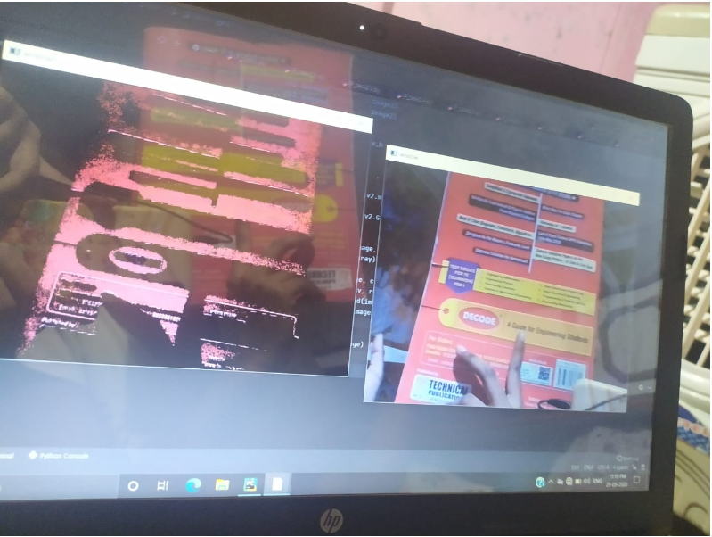

**19th September 2020– 23th September 2020**

We searched for methods to mask specific color using mouse event but it dosen’t seem to work therefore as per suggestion given by mentor we tried getting pixel value on click and then masking the all pixel 40<pixel value <40 but didn’t got success as we expected . after some hit-and try we got 60<pixal value<60 this method

**24 th September 2020**

Presented output of the previous code. Some improvements suggested and further task given by mentors as follows:

1. Create another window to show real time color masking
2. And show mask color as it in the window without turning it into Gray image .

**25th September 2020– 29th September 2020**

we completed task with given improvements

**Task completion timeline**

**14th Sept 2020 – Successfully implemented filter on image using mouse event ,started working for real time**

**23st September 2020 - Successfully implemented specific color masking in real time**

**29nd September 2020- Successfully implemented suggested improvements in the previous code.**

---------------------------------------------------------------------------------------------------------------------------------------